LATE ENTRY FORM
GUERNSEY WORLD AID WALK

in support of
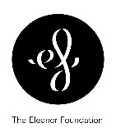 |  | 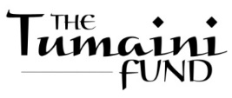
Notes for completing this form:
£15 per ADULT 19+
£5 per 18 and under

- Every walker must be allocated their own individual number.
- Every form must be signed by all adult walkers.
- Are you younger than 16? If so, you need a parent’s / guardian’s signature.
- Is your child in year 5 or below? If so, they must be accompanied by an adult (18+).
- This adult must be identified on the form and be issued with their own number.
NUMBER ALLOCATED:
BOX FOR
YOU TO WRITE NUMBERS ALLOCATED
NAME: ..................................................................DOB
11/05/04 → 31/8/09
check for adult signature
1/9/09 onwards
must be accompanied
NAME: ..................................................................DOB ..............................
NAME: ..................................................................DOB ..............................
NAME: ..................................................................DOB ..............................
SCHOOL(S) please*: .......................................................................................................
EMERGENCY CONTACT PHONE NUMBERS
EMAIL: …………………………………………………..…………………………………………………….…..
ORGANISATION OR TEAM NAME (if any)*: .............................................................
SIGNATURE OF WALKERS: DATE:
In the case of walkers under 16 years of age DECLARATION OF PARENT/GUARDIAN:
I hereby give my consent that the above named person can take part in the World Aid Walk. I also take responsibility for collection and prompt payment of sponsorship.
SIGNATURE OF PARENT/GUARDIAN :

DISCLAIMER: All participants in the Walk take part at their own risk and the organisers and committee of the World Aid Walk accept no responsibility for personal accidents. Care will be taken by the organisers to try to ensure the safety of walkers, but I hereby indemnify the organisers from and against any liability arising from my / my child’s participation in the Walk. The World Aid Walk Committee are collecting your information for the purposes of the Walk. It will not be passed to any third parties without your prior consent.
:

